Physics 20 Lesson 31 Resonance and Sound

# Standing waves

Refer to Pearson pages 416 to 424 for a discussion of standing waves, resonance and music.

The amplitude and wavelength of interfering waves are often different. But waves with the same amplitude and wavelength travelling in opposite directions results in an interesting interference pattern called a **standing wave interference pattern** or simply a **standing wave**. In interference pattern 1 below we have two waves of identical amplitude and wavelength travelling in opposite directions. However, since the waves are completely out-of-phase complete destructive interference occurs at every point resulting in zero displacement. 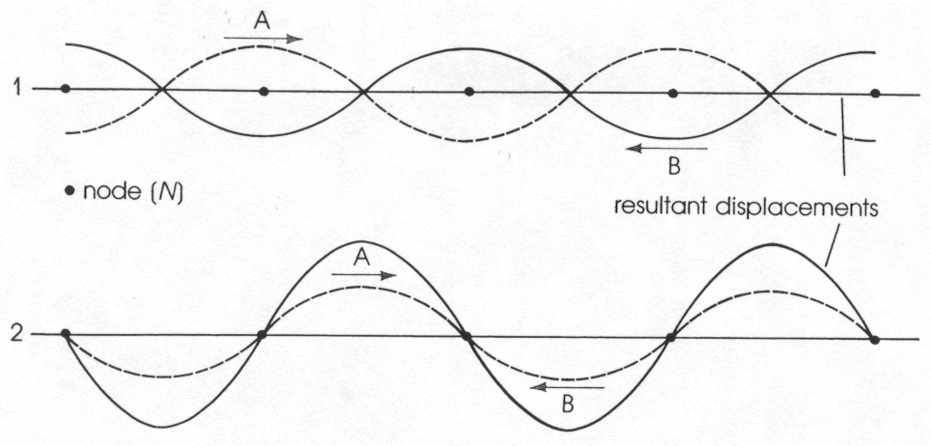

For interference pattern 2, the waves are in-phase resulting in complete constructive interference.

Standing, or stationary, wave patterns can be observed on a stretched string or wire that is fixed at both ends. The frequencies at which standing waves can exist in a string of a given length are the **natural** or **resonant** frequencies of the string. When energy is added to the string, the initial wave goes down the string and reflects from the fixed end. The reflected wave interferes with the incident wave. If the waves are at the **fundamental** **frequency** or if they have one of a number of **overtone** **frequencies**, a stationary wave results. Check out videos P20 L31 Standing Waves A and B on D2L.

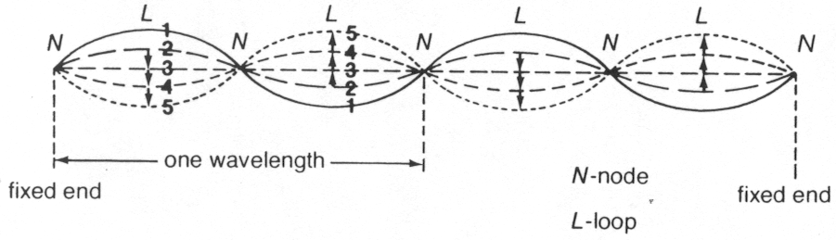

The fundamental frequency is called the first harmonic.

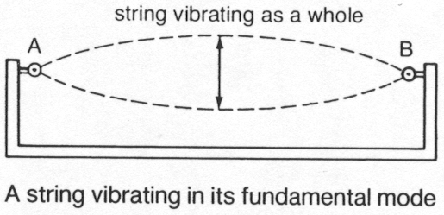

The overtones are called the second harmonic, third harmonic, fourth harmonic, etc.

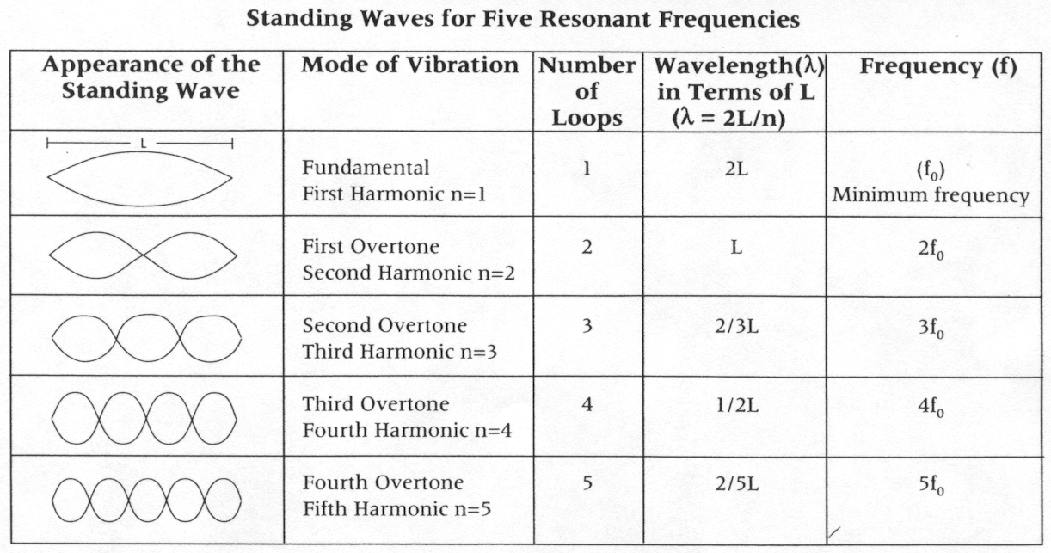

For a standing wave pattern to exist, the number of wavelengths on the string depends on the length (L) of the string. The first harmonic (n=1) has ½ a wavelength on the string:



The second harmonic (n=2) has 1 wavelength on the string:

2 = L

The general equation that emerges is:

 where n = 1, 2, 3 …

What is the wavelength of the 4th harmonic on a 2.4 m string?

 = **1.2 m**

A 3rd harmonic standing wave appears on a 1.80 m string when the frequency is 32 Hz. What is the speed of a wave on the string?

First find the wavelength:

 = 1.20 m

Using the universal wave equation:

v = f  = 32 Hz (1.20 m) = **38.4 m/s**

# Resonance

Every object has a natural or **resonant** frequency at which it will vibrate. To keep a child moving on a swing, we have no choice but to push the swing at its natural frequency. It will not vibrate at any other frequency. Consider the apparatus below:

A

B

C

D

Pendulums A and C have the same length and, therefore, the same natural frequency of vibration. When A is set in vibration, C begins to vibrate in time with A. B and D may move a small amount, but they do not continue to vibrate, nor do they vibrate as much. Similarly, if B is set in vibration, pendulum D will start to vibrate with B. Check out the video clip called P20 L31 Coupled pendulums on D2L.

An explanation of this behaviour involves a phenomenon called **resonance**. A and C are in resonance because they both have the same natural frequency. The energy from A is transferred along the support string to B, C and D, but the only pendulum that can respond is the one that has the same frequency of vibration as the energy from A.

# Resonance in air columns

If an air column is closed at one end and open at the other, it is referred to as a **closed air column**. When a vibrating tuning fork is held over the open end of such a column and the length of the column is changed, it is found that the loudness increases sharply at very specific lengths. The increased loudness is due to resonance at that length. Like transverse waves on a string, longitudinal sound waves can also form standing or resonant waves.

As seen in the diagrams below, for a **closed air column** resonance first occurs when the column is 1/4  in length. The next resonant lengths occur at 3/4 , 5/4  and so on.

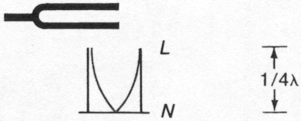

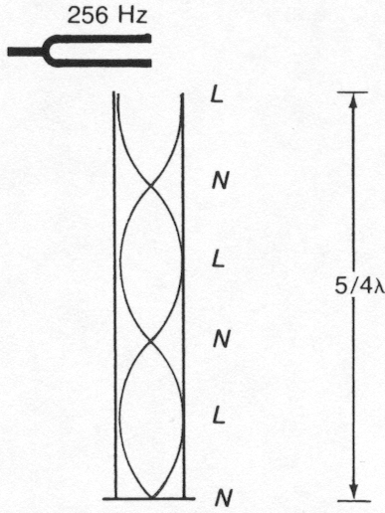

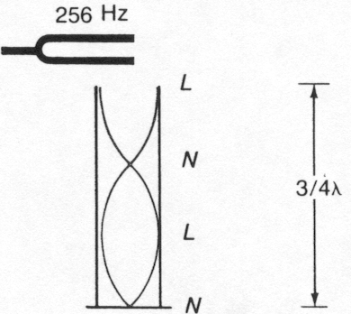

For an **open air column** resonance first occurs when the column is ½  in length. The next resonant lengths occur at , 3/2  and so on.

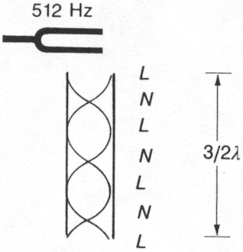

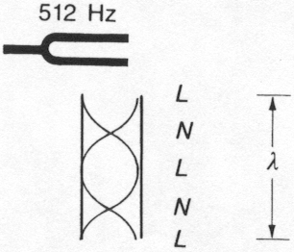

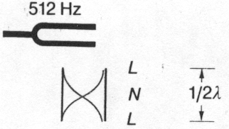

The equations that relate resonant length (L) with wavelength () are:

closed air column  n = 1, 2, 3 …

open air column  n = 1, 2, 3 …



The first resonant length of a closed air column occurs when the length is 18 cm.

(a) What is the wavelength of the sound? (b) If the frequency is 512 Hz, what is the speed of sound in air?

(a) 

● = 4 L = 4(0.18 m) = **0.72 m**

(b) v = f  = 512 Hz(0.72 m) = **369 m/s**

An organ pipe, 3.6 m long, open at both ends, produces a note at the fundamental frequency. (a) What is the wavelength of the note produced? (b) If the speed of sound is 346 m/s, what is the frequency of the pipe?

(a) 

● = 2 L = 2(3.6 m) = **7.2 m**

(b) = **48 Hz**

In musical instruments the same note played on a clarinet does not sound the same as the note played on a saxophone. This is dues to the presence of overtones being superimposed on the fundamental note.

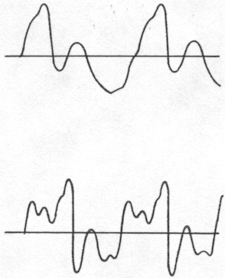

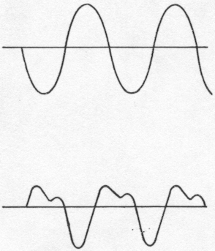

clarinet

violin

organ pipe

tuning fork

Check out the **very cool** video clips called P20 L31 Sound Waves, P20 L31 Sound shatters a wine glass, P20 L31 2D Resonance and P20 L31 Tacoma Narrows Bridge Collapse on D2L.

# Hand-in assignment

1. A fundamental frequency of 300 Hz is produced on a violin string. What are the 3rd and 4th harmonics? (900 Hz, 1200 Hz)

2. The 3rd harmonic on a piano string occurs when a 45 cm wave is produced. How long is the string? (67.5 cm)

3. The fundamental frequency is produced on a 75.0 cm guitar string. What is the wavelength of the wave on the string? If the frequency is 252 Hz, what is the speed of the wave on the string? (150 cm, 378 m/s)

4. The first resonant length of a closed air column occurs when the length is 30 cm. What will the second and third resonant lengths be? (90 cm, 150 cm)

5. The third resonant length of a closed air column is 75 cm. Determine the first and second resonant lengths. (15 cm, 45 cm)

6. What is the shortest closed air column that will resonate at a frequency of 440 Hz when the speed of sound is 352 m/s? (20.0 cm)

7. The second resonant length of an air column open at both ends is 48 cm. Determine the first and third resonant lengths. (24 cm, 72 cm)

8. An organ pipe, open at both ends, resonates at its first resonant length with a frequency of 128 Hz. What is the length of the pipe if the speed of sound is 346 m/s? (1.35 m)